Anomaly Detection in Credit Card Transactions: Leveraging Machine Learning for Fraud Classification

MATHAN KUMAR THAVU MUDALIAR KANAGARAJ
BELLEVUE UNIVERSITY
DSC 680 APPLIED DATA SCIENCE
PROF. AMIRFARROKH IRANITALAB
02/26/2026

Topic

This project is titled "Anomaly Detection in Credit Card Transactions: Leveraging Machine Learning for Fraud Classification", a machine learning project that applies supervised classification models including Logistic Regression, Random Forest, XGBoost, and Gradient Boosting to detect and classify fraudulent credit card transactions from a synthetic dataset of 10,000 transactions across behavioral and transactional features.

Business Problem

Traditional rule-based fraud detectors often fall behind increasingly sophisticated scams, producing many false positives that interfere with legitimate transactions while missing real fraud. This project addresses that gap by building a machine learning classifier that uses behavioral and transactional features—such as transaction amount, device trust score, location mismatch, foreign transaction status, and transaction hour—to distinguish fraudulent from legitimate activity more accurately. The core research questions include: which transactional and behavioral features most strongly predict fraud and how do they interact; how do models like Logistic Regression, Random Forest, and XGBoost compare in detection accuracy and which yields the best performance; whether high-risk indicators (e.g., transactions between 1 AM and 5 AM, foreign transactions, location mismatches) amplify fraud risk; and whether cardholder demographics (age and senior status) help identify groups that are more frequently targeted.

Background
Credit card fraud has become one of the most pervasive and costly financial crimes in the modern economy. Global payment card fraud losses reached $33.41 billion in 2024, and the Nilson Report projects these losses will rise to $41.06 billion by 2030 and $49.13 billion by 2034. Despite the United States accounting for only 26.31% of total card transaction volume worldwide, it bears 41.87% of global fraud losses.
In 2024 alone, the FTC received over 458,000 credit card fraud reports from U.S. consumers, with cardholders aged 60–69 reporting the highest dollar losses, exceeding $1.1 billion. Beyond direct financial losses, each dollar lost to fraud costs merchants a total of $3.75 when accounting for chargebacks, investigation costs, and operational overhead.

Dataset

The dataset used in this project is sourced from Kaggle, a widely recognized open-source platform for data science and machine learning datasets, and is publicly available at Kaggle. The dataset is a synthetic credit card transaction dataset specifically designed for fraud detection research and classification modeling. It contains 10,000 transaction records across 10 features, capturing a combination of transactional, behavioral, and demographic attributes that are commonly associated with fraudulent activity in real-world financial systems.

Target Variable is a binary target variable (0 = legitimate, 1 = fraudulent), with 9,849 legitimate and 151 fraudulent transactions representing a severe class imbalance of approximately 98.5% to 1.5%.

Key Features includes transaction_id serves as a unique identifier for each transaction, aiding in record identification, but it is dropped during preprocessing because it lacks predictive value. The amount represents the monetary value of each transaction in US dollars, with a range from $0.00 to $1,471.04 and a mean value of $175.95. The transaction_hour indicates the hour of the day (from 0 to 23) when the transaction took place, which is used to create a high-risk time window indicator for transactions occurring between 1 AM and 5 AM.

The merchant_category categorizes the merchant involved in the transaction into one of five types: Electronics, Travel, Grocery, Food, and Clothing, and these categories are encoded using One-Hot Encoding for modeling purposes. Additionally, the foreign_transaction is a binary indicator (0 or 1) that shows whether the transaction occurred in a foreign country, while the location_mismatch indicator (also binary) indicates if the transaction location did not align with the cardholder's registered address.

The device_trust_score is a numerical score, ranging from 1 to 100, reflecting the trustworthiness of the device used for the transaction, with lower scores signaling a higher level of risk. The velocity_last_24h captures the number of transactions made by the cardholder in the previous 24 hours, identifying unusual spending velocity as a potential fraud signal. Lastly, the cardholder_age records the age of the cardholder in years, which is leveraged to engineer an indicator for senior citizens, specifically for those aged 65 and above.

Data Preprocessing
In the Data Preprocessing phase of the credit card fraud dataset, a systematic and comprehensive approach was employed to ensure data quality and model readiness. The process began with data discovery, where the dataset was validated for shape, data types, duplicate records, and missing values. The dataset was confirmed to contain 10,000 transaction records across 10 features with no missing values and no duplicate rows, establishing a clean foundation for subsequent preprocessing steps.
The first preprocessing step involved dropping the transaction_id column, as it serves solely as a unique row identifier and carries no predictive value for fraud classification. This reduced the feature space to 9 meaningful columns for further processing.
Categorical encoding was then performed on the merchant_category feature, which contained five text-based categories such as Electronics, Travel, Grocery, Food, and Clothing. One-Hot Encoding was applied to generate all five binary indicator columns, retaining the original merchant_category column alongside the encoded columns to preserve interpretability for exploratory analysis.
Feature engineering was conducted to derive two new binary risk indicators from existing columns. The transaction_hour_risk_indicator was created to flag transactions occurring between 1 AM and 5 AM as high risk (1) and all other hours as low risk (0), based on the hypothesis that fraudulent transactions are more likely to occur during off-peak hours when cardholders are less likely to notice unauthorized activity.
The cardholder_senior_citizen feature was engineered to flag cardholders aged 65 and above (1) to examine whether older demographics are disproportionately targeted in fraudulent transactions.

Feature scaling was subsequently applied to address the significant differences in magnitude across continuous numerical features. StandardScaler from Scikit-learn was used to standardize amount, device_trust_score, cardholder_age, and velocity_last_24h, generating four new scaled columns such as amount_scaled, device_trust_score_scaled, cardholder_age_scaled, and velocity_last_24h_scaled while retaining the original unscaled columns for reference and exploratory analysis purposes.

Class Balancing
Given the severe class imbalance in the dataset with only 1.5% of transactions labeled as fraudulent (151 out of 10,000), SMOTE (Synthetic Minority Oversampling Technique) was applied exclusively on the training data within a pipeline to synthetically generate minority class samples and achieve a balanced 50/50 class distribution, preventing data leakage into the test set. The dataset was split into training and testing sets using a 70-30 split ratio with random_state=42 for reproducibility.

Methods
A comprehensive end-to-end machine learning pipeline was implemented, encompassing data preparation, exploratory data analysis, feature engineering, class imbalance handling, modeling, and rigorous evaluation. The project follows established best practices in supervised binary classification, with is_fraud as the target variable to predict whether a given credit card transaction is fraudulent or legitimate.
Three classification models were developed and evaluated to identify the best performing approach for fraud detection. Logistic Regression was implemented as the linear baseline model using a pipeline with StandardScaler normalization and a maximum of 200 iterations, serving as the benchmark for more complex models. XGBoost Gradient Boosting was deployed as an advanced ensemble classifier leveraging sequential boosting techniques to iteratively improve predictions by learning from previous model errors, configured with logloss as the evaluation metric. Random Forest with SMOTE was implemented as a bagging ensemble approach combining multiple decision trees with class_weight = 'balanced' for a double layer of imbalance correction, further strengthened through hyperparameter tuning.
In the hyperparameter optimization phase, model performance was optimized through a combined data, modeling, and tuning approach; first the severe class imbalance was corrected with SMOTE, engineered risk features (e.g., transaction_hour_risk_indicator, senior_citizen flag), one‑hot encoded categories, and scaled numerical inputs so models trained reliably; next we evaluated multiple baselines (Logistic Regression, a random baseline) and a strong learner (XGBoost) to select the best model class; and finally we ran GridSearchCV with StratifiedKFold to tune XGBoost hyperparameters (n_estimators, learning_rate, max_depth, subsample, colsample_bytree, min_child_weight, gamma) using cross‑validated F1 as the objective, then retrained the best estimator and evaluated it on the hold‑out test set, yielding substantially improved metrics (F1 ≈ 0.9974, accuracy ≈ 0.9975) and far fewer false positives/negatives.
All models were evaluated using a consistent framework of Accuracy, Precision, Recall, F1 Score, and Confusion Matrix to enable direct and transparent comparison across classifiers. Given the cost asymmetry inherent in fraud detection where a missed fraudulent transaction carries significantly greater consequences than a false alarm, Recall and F1 Score were treated as the primary performance indicators rather than Accuracy alone, ensuring the evaluation framework remained aligned with the real-world priorities of financial fraud prevention.

Analysis
In the Exploratory Data Analysis phase, nine graphical representations were employed to uncover patterns, relationships, and anomalies within the credit card fraud dataset, focusing on class distribution analysis, univariate analysis, bivariate analysis, and multivariate analysis.
Univariate analysis was conducted through KDE plots to examine the distribution of individual continuous features split by fraud status. The Device Trust Score Distribution KDE plot revealed whether lower trust scores were concentrated among fraudulent transactions, validating the feature's predictive importance. The Cardholder Age Distribution KDE plot examined whether certain age groups, particularly senior citizens aged 65 and above were more frequently targeted in fraudulent activity, supported by a shaded region highlighting the senior citizen threshold and summary statistics on the senior citizen fraud rate.
Bivariate analysis explored the relationships between individual features and the fraud target variable through multiple chart types. The Transaction Amount Distribution by Fraud Status box plot compared the spread, median, and outliers of transaction amounts across legitimate and fraudulent transactions, annotated with median values and summary statistics for each class. The Fraud Rate by Transaction Hour line chart plotted fraud rates across all 24 hours, with a highlighted red shading over the 1 AM to 5 AM window to validate the transaction_hour_risk_indicator engineered feature and an average fraud rate reference line for comparison. The Fraud Rate by Merchant Category bar chart ranked all five merchant categories by their fraud rate percentage, identifying which categories were most associated with fraudulent activity relative to the overall average. The Fraud Rate by Foreign Transaction and Location Mismatch bar chart compared fraud rates across the four combinations of the two binary risk indicators, assessing whether these features compound each other's effect on fraud likelihood.
Multivariate analysis was conducted through a correlation heatmap and a scatter plot to examine relationships across multiple features simultaneously. The Correlation Heatmap visualized pairwise correlations between all key numerical features and is_fraud using a Red-Yellow-Green colormap, with a summary bar identifying the strongest fraud predictors by correlation coefficient. The Transaction Amount vs Device Trust Score scatter plot placed each transaction on a two-dimensional plane colored by fraud status, with mean reference lines dividing the plot into four quadrants to reveal whether fraudulent transactions clustered in the high-amount, low-trust-score region the most concerning combination from a fraud risk standpoint.
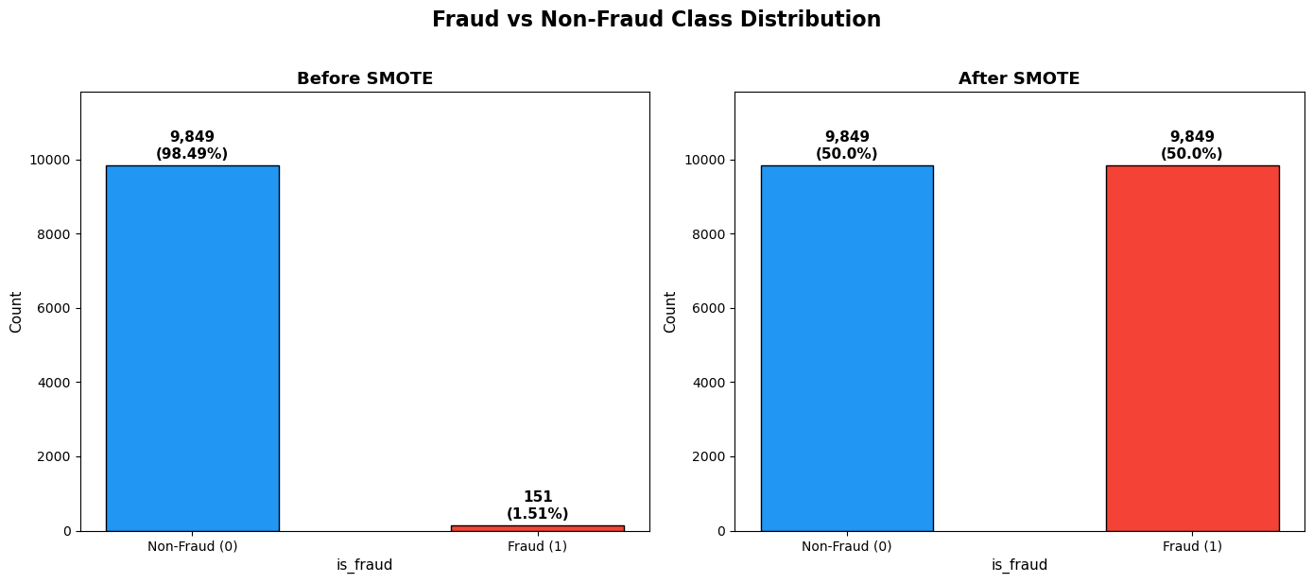
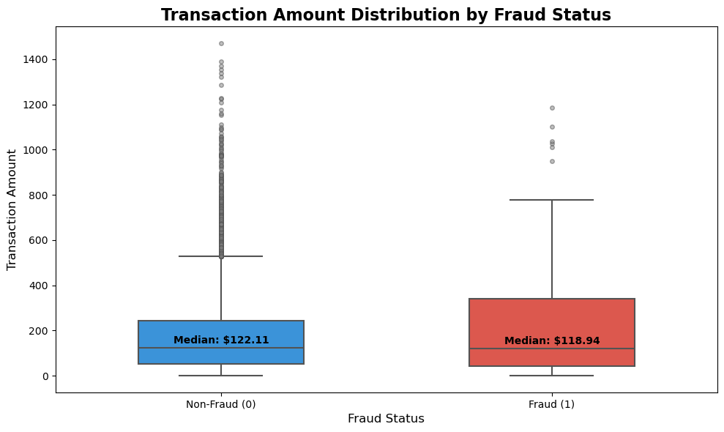
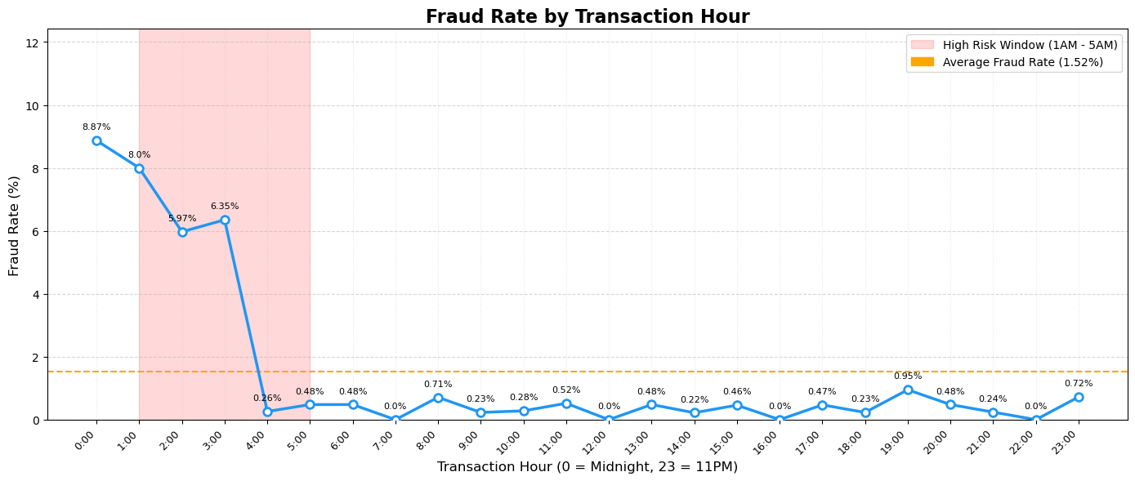

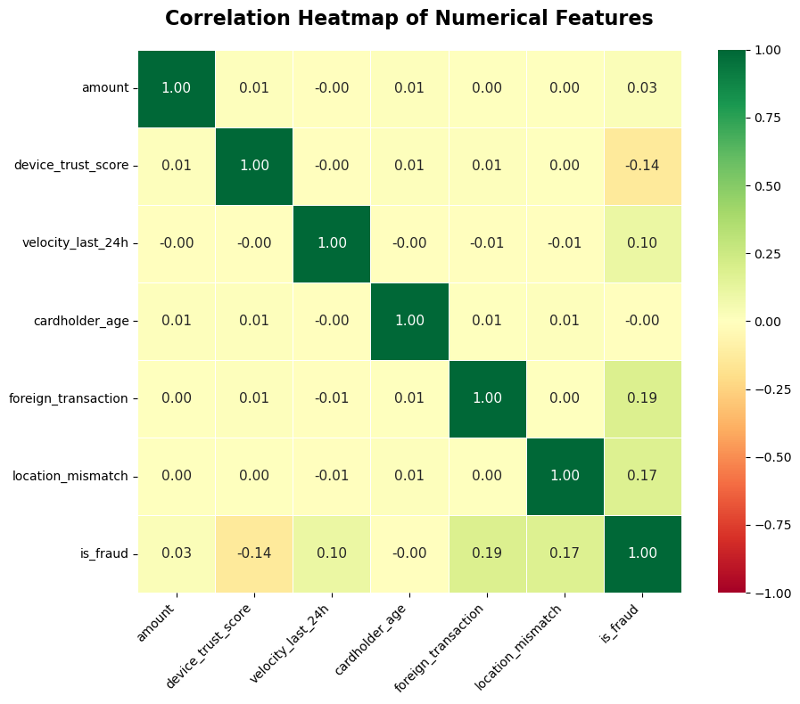
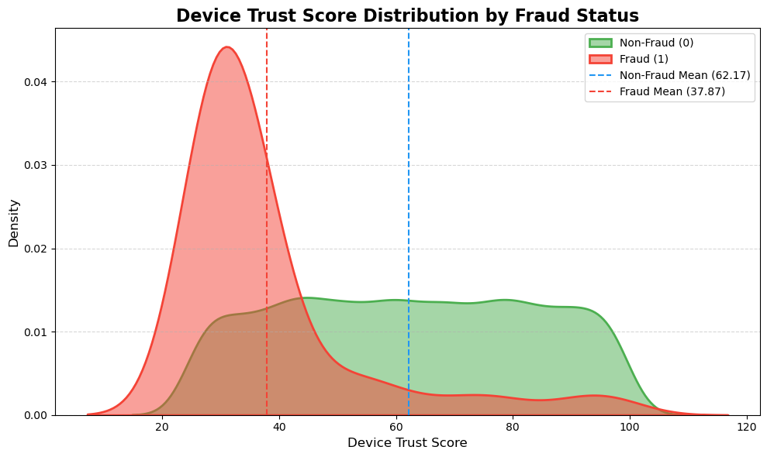
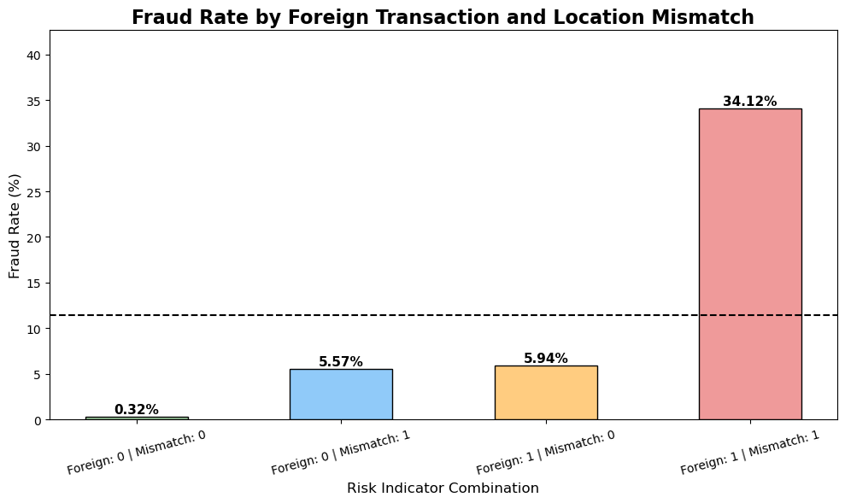
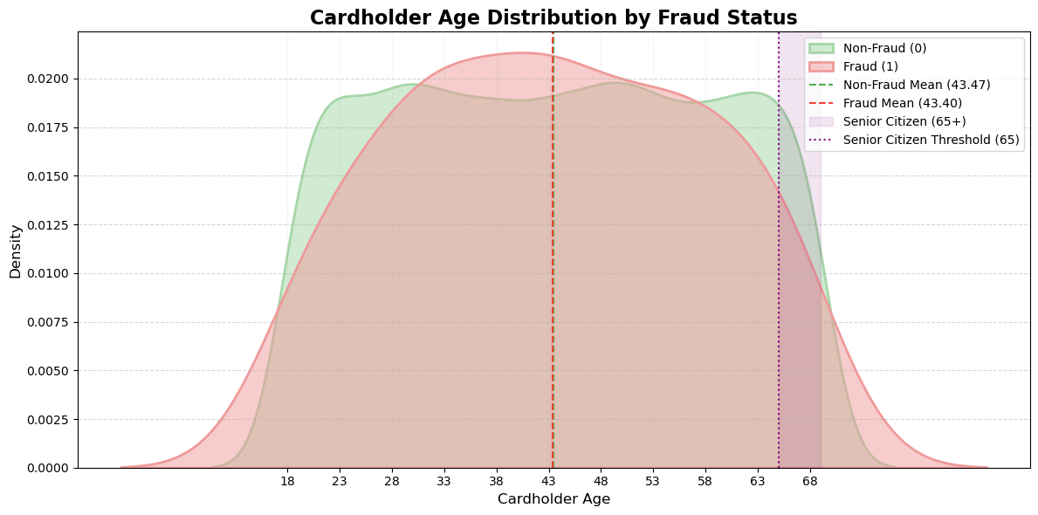
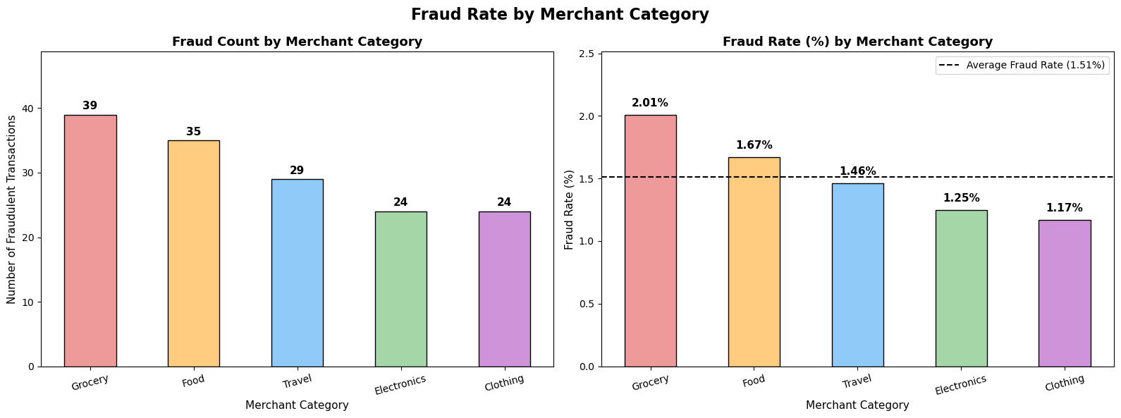
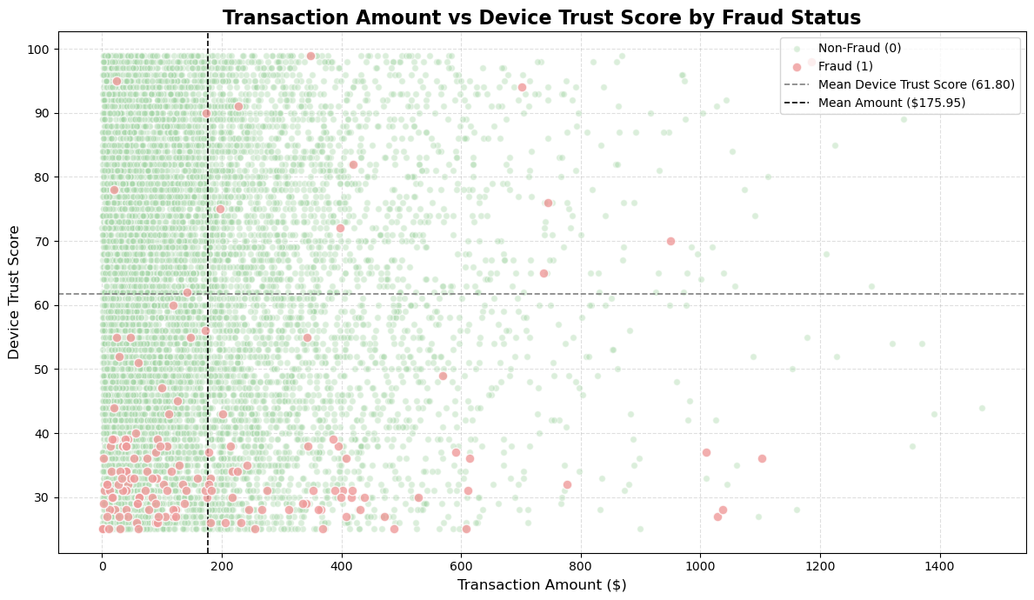

Conclusion

The project "Anomaly Detection in Credit Card Transactions: Leveraging Machine Learning for Fraud Classification" aims to leverage machine learning techniques to detect and classify fraudulent credit card transactions. Through a comprehensive analysis involving univariate, bivariate, and multivariate exploratory methods, the study uncovers valuable insights about how features such as transaction amount, device trust score, transaction hour, foreign transaction status, and location mismatch contribute to fraud risk. By employing models including Logistic Regression, Random Forest with SMOTE, and XGBoost Gradient Boosting alongside hyperparameter tuning and class imbalance correction techniques, the findings provide actionable insights for financial institutions seeking to strengthen their fraud detection pipelines, reduce financial losses, and improve cardholder protection.

Assumptions
The project assumes that the synthetic dataset accurately reflects the behavioral and transactional patterns of real-world credit card fraud, capturing the essential features and relationships that distinguish fraudulent transactions from legitimate ones. Additionally, the analysis assumes that SMOTE-generated synthetic samples adequately represent the minority fraud class and that the class distribution in the test set accurately reflects the real-world imbalance of fraudulent versus legitimate transactions. The project further assumes that the selected features collectively contain sufficient discriminative signal to distinguish between fraudulent and legitimate transactions, and that the relationships learned during training remain stable and applicable to unseen transaction data.

Limitations
The primary limitation is the synthetic nature of the dataset, which may not fully capture the complexity, noise, and constantly evolving tactics present in real-world credit card fraud, potentially limiting the generalizability of the trained models to live production environments. The severe class imbalance with only 1.5% of transactions labeled as fraudulent poses a persistent modeling challenge, as even after SMOTE correction, synthetic samples may introduce noise that does not accurately represent genuine fraudulent behavior. Finally, the use of black-box ensemble models such as XGBoost and Random Forest limits model interpretability, making it difficult to provide transparent and explainable fraud flagging decisions, a critical requirement in real-world financial applications.

Challenges/Issues
Severe Class Imbalance - Only 1.5% of transactions labeled as fraudulent (151 out of 10,000), class imbalance is the most immediate and persistent challenge in this project. Models trained on heavily imbalanced data tend to be biased toward the majority class, achieving high accuracy by simply predicting every transaction as legitimate while failing to detect actual fraud. While SMOTE will be applied to address this, synthetic oversampling introduces its own risks such as overfitting on artificially generated samples that may not accurately represent real fraudulent behavior.
Generalizability of a Synthetic Dataset - Dataset used in this project is synthetically generated, meaning it may not fully capture the complexity, noise, and evolving nature of real-world fraudulent transaction patterns. Models trained on synthetic data may not generalize well to live production environments where fraud tactics are constantly adapting, transaction volumes are significantly larger, and feature distributions may differ substantially from those in the training data.
Overfitting vs. Underfitting - Balancing model complexity is a persistent challenge in fraud detection. Simple models like Logistic Regression may underfit and fail to capture non-linear fraud patterns, while complex ensemble models like Random Forest and XGBoost risk overfitting — particularly after SMOTE oversampling introduces synthetic samples. Careful cross-validation, regularization, and hyperparameter tuning will be required to find the right balance between bias and variance.

Future Use Cases
The insights gained from this project on detecting fraudulent credit card transactions using machine learning can be leveraged for various future applications in the financial services industry. One significant application is in real-time fraud detection systems, where the trained classification models can be integrated into live transaction processing pipelines to flag suspicious transactions instantaneously at the point of sale. By deploying models such as Random Forest or XGBoost within a streaming data architecture, financial institutions can intercept fraudulent transactions before they are completed, dramatically reducing financial losses and improving cardholder protection.
There is also an opportunity for the development of personalized fraud risk scoring systems. By incorporating additional behavioral and demographic data such as spending history, device fingerprinting, and geographic patterns institutions can generate dynamic fraud risk scores for each cardholder, enabling more nuanced and accurate fraud assessments that adapt to individual spending behaviors rather than applying uniform thresholds across all customers.
Feature engineering techniques developed in this project, particularly the time-based and demographic risk indicators can serve as a foundation for broader anomaly detection applications across other financial products such as insurance claims, loan applications, and digital wallet transactions.
Recommendation
Financial institutions should invest in continuous model retraining by regularly updating predictive models with new transaction data to ensure they remain responsive to evolving fraud tactics and changing cardholder behaviors. Exploring additional features such as social media activity, device fingerprinting, merchant reputation scores, and network-based transaction relationships could significantly enrich the feature space and improve model discriminative power beyond what the current dataset provides. Addressing the model interpretability gap by incorporating explainability frameworks such as SHAP (SHapley Additive exPlanations) or LIME (Local Interpretable Model-Agnostic Explanations) is strongly recommended, as transparent and auditable fraud decisions are both an ethical obligation and an increasing regulatory requirement in the financial industry.

Implementation Plan

The successful deployment of the credit card transactions classification models requires a structured and phased implementation plan to transition from research prototypes to operational use. In Phase 1: Model Finalization and Validation (1–3 months), the project team will focus on selecting and finalizing the top-performing model, which is likely to be XGBoost due to its robustness. The model will be retrained on the full preprocessed dataset, ensuring that class imbalance is addressed through techniques such as class weighting or stratified sampling, enhancing reliability without heavily relying on synthetic oversampling. Phase 2: Interpretability and Compliance (1–2 months) will integrate explainability tools like SHAP or LIME into the model framework, allowing for the generation of feature importance rankings and individual prediction explanations. In Phase 3: System Integration and Pilot Deployment (3–6 months), the finalized model will be integrated into existing systems, establishing continuous monitoring pipelines to track model drift and overall prediction accuracy. A pilot deployment will enable real-world testing, allowing for evaluation of model performance against live outcomes. Phase 4: Monitoring, Retraining, and Scaling (Ongoing) will involve ongoing monitoring to detect any performance drift as new data is introduced. Regular retraining sessions will be scheduled to incorporate fresh data and maintain accuracy.

Ethical Considerations

Algorithmic and Demographic Bias - Fairness Features such as cardholder age, foreign transaction status, and location mismatch risk introducing demographic bias into the model, potentially flagging legitimate transactions from certain groups such as senior citizens or frequent travelers at a disproportionately higher rate. Care must be taken to ensure the model is making decisions based on genuine fraud signals rather than demographic characteristics.

False Positives and Customer Impact - Optimizing for recall to catch more fraud can inadvertently generate excessive false positives, resulting in declined transactions and frozen accounts for legitimate customers. Striking the right balance between precision and recall is not just a modeling concern but an ethical one, as aggressive fraud flagging can significantly disrupt the financial lives of innocent cardholders.

Transparency and Explainability - Black-box models such as XGBoost and Random Forest are difficult to interpret, raising ethical and legal concerns in contexts where cardholders have a right to understand why their transactions were flagged or declined. Financial institutions are increasingly obligated to provide explainable and auditable model decisions, making interpretability as important as predictive performance.

Surveillance and Profiling - The use of behavioral features such as transaction velocity, device trust scores, and location data raises broader concerns about customer profiling without explicit consent. While such monitoring serves a protective purpose, the line between fraud prevention and invasive surveillance must be carefully managed to preserve customer trust and uphold individual privacy rights.

Important References
- Primary Data Source
Miah, A. (2025). Credit Card Fraud Detection Dataset. Kaggle.com.

https://www.kaggle.com/datasets/miadul/credit-card-fraud-detection-dataset/data
- Other Reference
The Nilson Report. (2026, January 7). Global Card Fraud Losses at $33 Billion. GlobeNewswire News Room; GlobeNewswire.

https://www.globenewswire.com/news-release/2026/01/07/3214821/0/en/Global-Card-Fraud-Losses-at-33-Billion.html

AInvest. (2026, January 7). Payment Card Fraud Losses Decline Globally to $33.41 Billion in 2024. AInvest.
https://www.ainvest.com/news/payment-card-fraud-losses-decline-globally-33-41-billion-2024-2601/
- Technical Reference
Md. Amirul Islam, Md. Ashraf Uddin, Aryal, S., & Stea, G. (2023). An ensemble learning approach for anomaly detection in credit card data with imbalanced and overlapped classes. Journal of Information Security and Applications, 78, 103618–103618. https://doi.org/10.1016/j.jisa.2023.103618

- Ethical Consideration
Fairness and machine learning. (n.d.). Fairmlbook.org.
https://fairmlbook.org

Anticipated Audience Questions

- What specific features have you identified as the most predictive of credit card fraud?

The correlation heatmap and exploratory analysis revealed that device_trust_score, location_mismatch, foreign_transaction, and velocity_last_24h were among the strongest predictors of fraudulent activity. Additionally, engineered features such as transaction_hour_risk_indicator and cardholder_senior_citizen contributed additional behavioral signals to the model's fraud detection capability.

- How do you ensure the integrity and accuracy of the data used in your models?

The dataset was thoroughly validated during the data discovery phase, confirming the absence of missing values, duplicate records, and inconsistent data types. A working copy of the original dataframe was preserved throughout preprocessing to maintain data integrity, and SMOTE was applied exclusively within the training pipeline to prevent any data leakage into the test set.

- What machine learning algorithms did you consider, and why?

Three models were evaluated, Logistic Regression as the linear benchmark, XGBoost Gradient Boosting to capture complex non-linear relationships, and Random Forest with SMOTE combining ensemble learning with class imbalance correction. Each model was selected to represent a progressively increasing level of complexity, enabling a structured comparison of performance across different algorithmic approaches.

- How do you address the severe class imbalance in the dataset?

The dataset exhibited a severe class imbalance with only 1.5% of transactions labeled as fraudulent. SMOTE was applied to synthetically oversample the minority fraud class in the training data, achieving a balanced 50/50 class distribution. Additionally, class_weight='balanced' was applied to the Random Forest model for a double layer of imbalance correction, and F1 Score was prioritized over Accuracy as the primary evaluation metric to better reflect model performance on imbalanced data.

- What are the primary limitations of your study, and how might they affect the results?

The primary limitations include using synthetic data that may not capture real-world fraud complexity and thus limit generalizability; a severe class imbalance (≈1.5% fraud) where SMOTE helps but can introduce unrealistic minority examples; and reliance on black‑box ensembles (XGBoost/Random Forest) that reduce interpretability and hinder transparent decisioning together these factors can inflate performance estimates, miss edge cases, and limit practical ability to deploy.

- What role does feature engineering play in improving your model's performance?

Feature engineering was a critical component of the preprocessing pipeline. The transaction_hour_risk_indicator captured the heightened fraud risk during off-peak hours between 1 AM and 5 AM, while cardholder_senior_citizen flagged a potentially vulnerable demographic group. These engineered features provided the models with additional behavioral context beyond the raw transaction attributes, enriching the feature space with domain-informed fraud signals.

- What actionable insights can financial institutions derive from your findings?

Financial institutions should prioritize monitoring transactions with low device trust scores, location mismatches, foreign transaction flags, and high velocity in the preceding 24 hours as high-risk signals. Transactions occurring between 1 AM and 5 AM and those involving senior citizen cardholders warrant additional scrutiny. These insights can inform the development of more targeted fraud alert rules and risk scoring systems that go beyond simple transaction amount thresholds.

- Can you elaborate on how transaction hour and cardholder age influence fraud likelihood?

The Fraud Rate by Transaction Hour line chart revealed that transactions occurring between 1 AM and 5 AM exhibited elevated fraud rates compared to daytime hours, validating the transaction_hour_risk_indicator feature. The Cardholder Age Distribution KDE plot examined whether senior citizens aged 65 and above were disproportionately targeted, with the senior citizen fraud rate summarized alongside the age distribution to assess the demographic dimension of fraud vulnerability.

- Which machine learning model performs best for detecting credit card fraud in this project?

Based on the project results, the XGBoost Gradient Boosting model performs best. It achieved the highest metrics on the test set (Accuracy 0.9963, Precision 0.9952, Recall 0.9972, F1 0.9962) and the best confusion matrix (very few false positives/negatives) compared with Logistic Regression (Accuracy ~0.9643, F1 ~0.9634) and the random baseline (~0.50).

- How was model performance optimized?

Model performance was optimized through a combined data, modeling, and tuning approach; first the severe class imbalance was corrected with SMOTE, engineered risk features (e.g., transaction_hour_risk_indicator, senior_citizen flag), one‑hot encoded categories, and scaled numerical inputs so models trained reliably; next we evaluated multiple baselines (Logistic Regression, a random baseline) and a strong learner (XGBoost) to select the best model class; and finally we ran GridSearchCV with StratifiedKFold to tune XGBoost hyperparameters (n_estimators, learning_rate, max_depth, subsample, colsample_bytree, min_child_weight, gamma) using cross‑validated F1 as the objective, then retrained the best estimator and evaluated it on the hold‑out test set, yielding substantially improved metrics (F1 ≈ 0.9974, accuracy ≈ 0.9975) and far fewer false positives/negatives.

